# CS 255 System Design Document

Victor Jarvis

## UML Diagrams

### UML Use Case Diagram

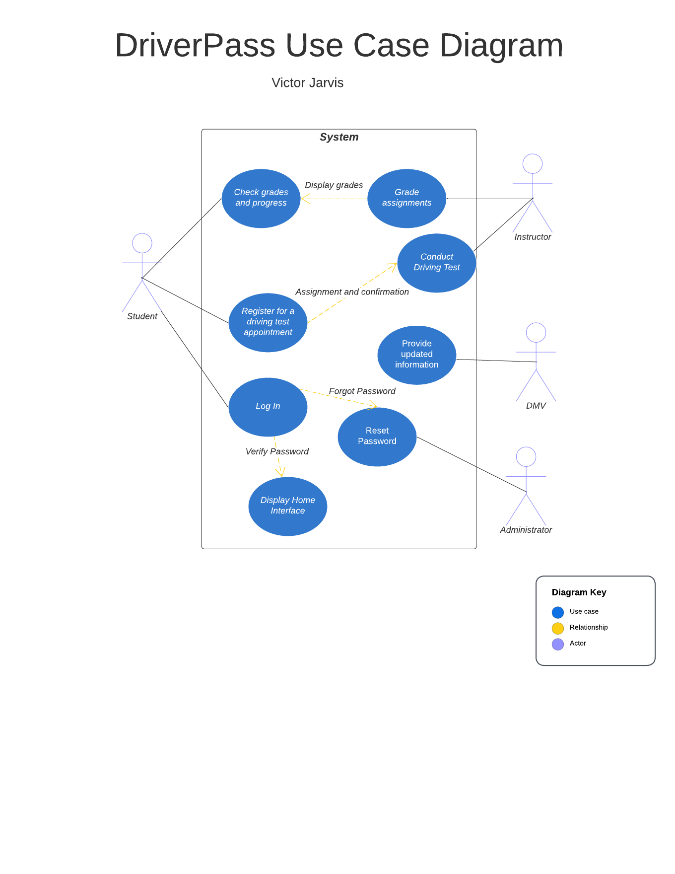

### UML Activity Diagrams

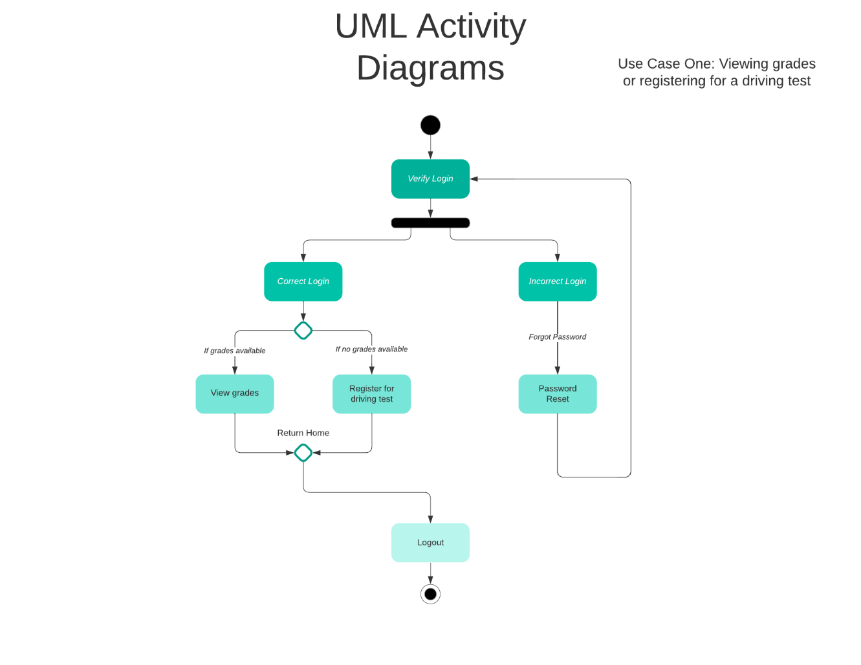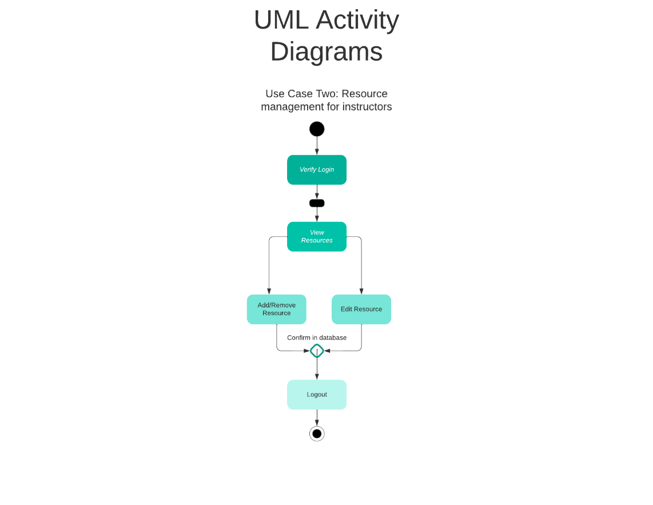

### UML Sequence Diagram

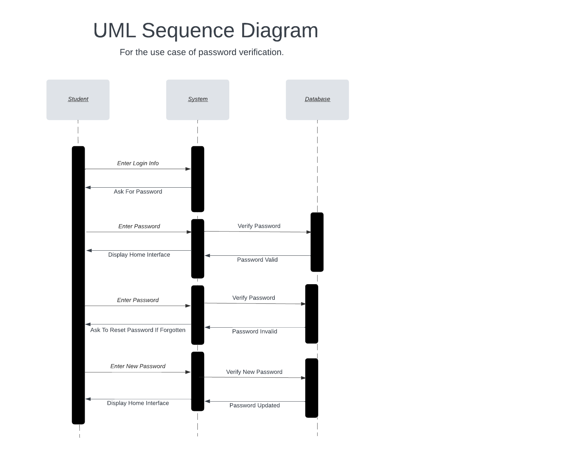

### UML Class Diagram

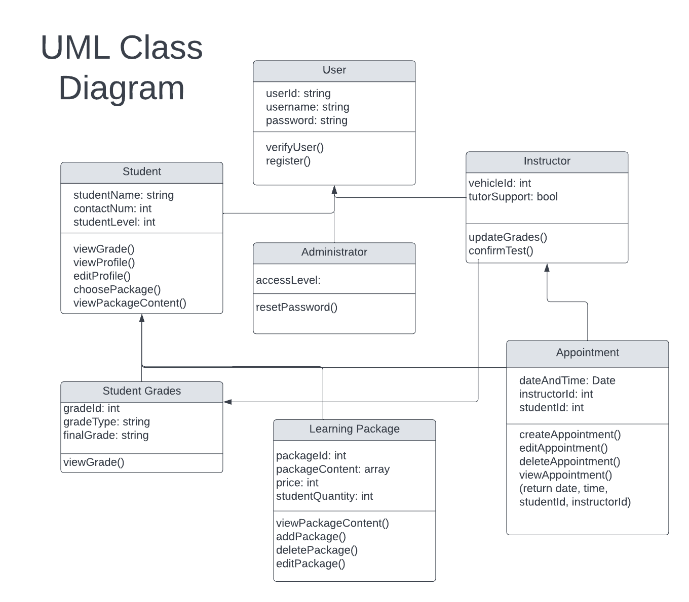

## Technical Requirements

Hardware should feature a physical server as well as support for cloud based server access. Administrators should have access to servers, power sources, and databases. Student clients should have a computer or phone with the ability to connect to the internet. The software requirements include an operating system such as Windows, installation and updating of the DriverPass application software. Additionally, all users should have access to a web browser if using a web based version of the application. Infrastructure should be able to handle an influx of users with minimal downtime, as well as security necessary to protect user information, content, and payment information. There should also be a consistent connection to the DMV in order to keep a consistent curriculum for students and instructors.